**Data Manipulation and Cleaning work**

**Account Table**

1. Convert the Date attribute into a yyyy-mm-dd by adding 23 in year format in Excel or SQL

=date(left(a1,2)+23,mid(a1,3,2),right(a1,2)).

Date_add(“940612”, Interval 23 Year).

1. Replace in frequency attribute “POPLATEK MESICNE” AS Monthly issuance, “POPLATEKTYDNE” AS weekly issuance, and “POPLATEK POBRATU” AS issuance after a transaction in Excel or create a case statement in SQL.

**CARD Table**

1. Replace type attribute value “junior” as Sliver, “Classic” as Gold,

And “Gold” as Diamond by using replace in Excel or by using update in SQL.

1. Convert issued attribute into yyyy-mm-dd adding 23 in year.

**CLIENT Table**

1. Convert bith_number attribute to yyyy-mm-dd format and also create another column named sex by applying in bith_number 0 for females and 1 for males.

(=if(mod(bith_number,2)=0, “Female”, “Male”) in excel or using case statement in SQL.

**DISTRICT Table**

1. Change all column names and delete the attributes a15 and a 16

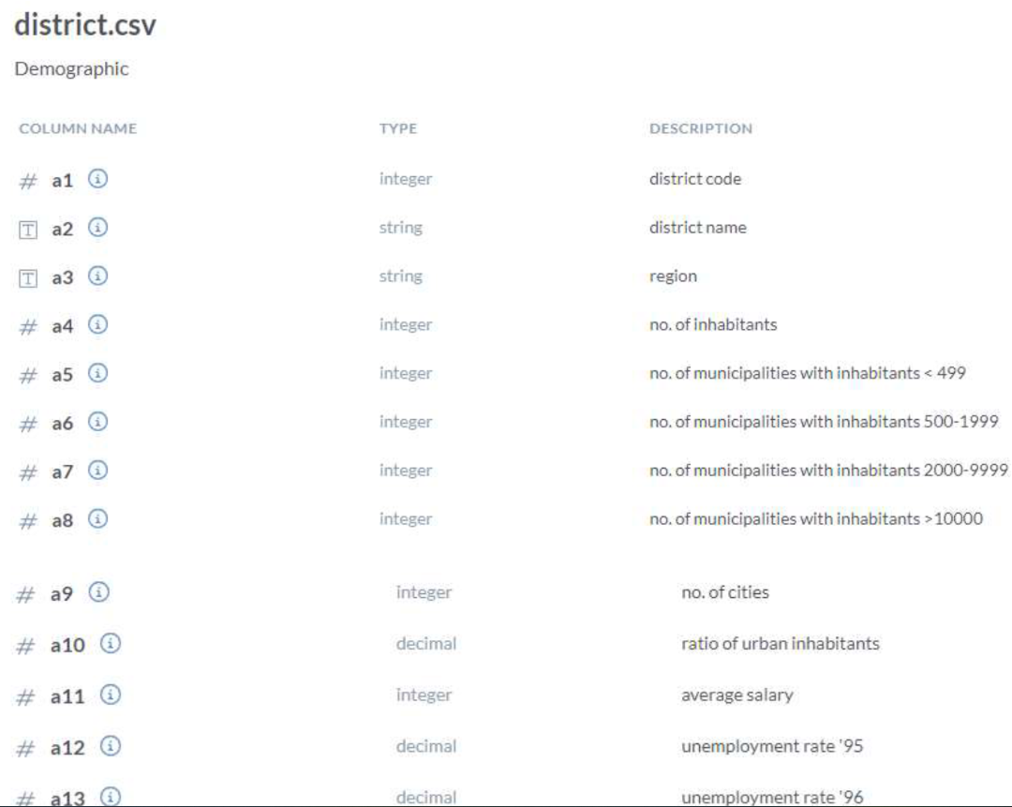

**LOAN Table**

1. Convert the Date Attribute into yyyy-mm-dd format adding 23 in year.
2. Convert Status Attribute value “A” as Contract Finished, “B” as Loan Not Paid, “C” as Running Contract, and “D” Client in debt.